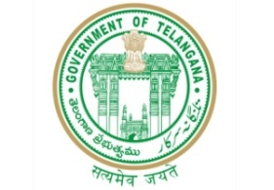**GOVERNMENT OF TELANGANA**

**TELANGANA TRIBAL WELFARE RESIDENTIAL DEGREE COLLEGE (GIRLS), MAHABUBABAD: MAHABUBABAD-DIST**

**https://www.ttwrdcs.ac.in/Mahabubabad**

**E-Mail Id:ttwrdcgirls.mahabubabad@gmail.com Cell No: 7901097695**

**SURVEY ACTIVITY**

Date : 02/02/24

Survey activity : Food Theme

Venue : TTWRDC (G) MHBD

Participants : 09

A survey on food Theme was done by students of statistics- II Year at TTWRDC (G) - Mahabubabad.

Questionnaire:

1. Do you like fast food?

2. Which is your favorite fast food?

3. Do you take brunch (or) breakfast?

4. Do you take breakfast every day?

5. Are you a vegetarian (or) Non-vegetarion?

6. What do you prefer vegetables (or) pulses?

7. What do you prefer rice (or) chapatti’s?

8. How often do you consume fast fool on a weekly basis?

9. Are you a good cook?

١٥٠ Do you brink milk (or) coffee?

Our group choose food Theme in the topic of eating habits. Because food is fundamental need for lives. If we don't care what we eat it may cause serious diseases.

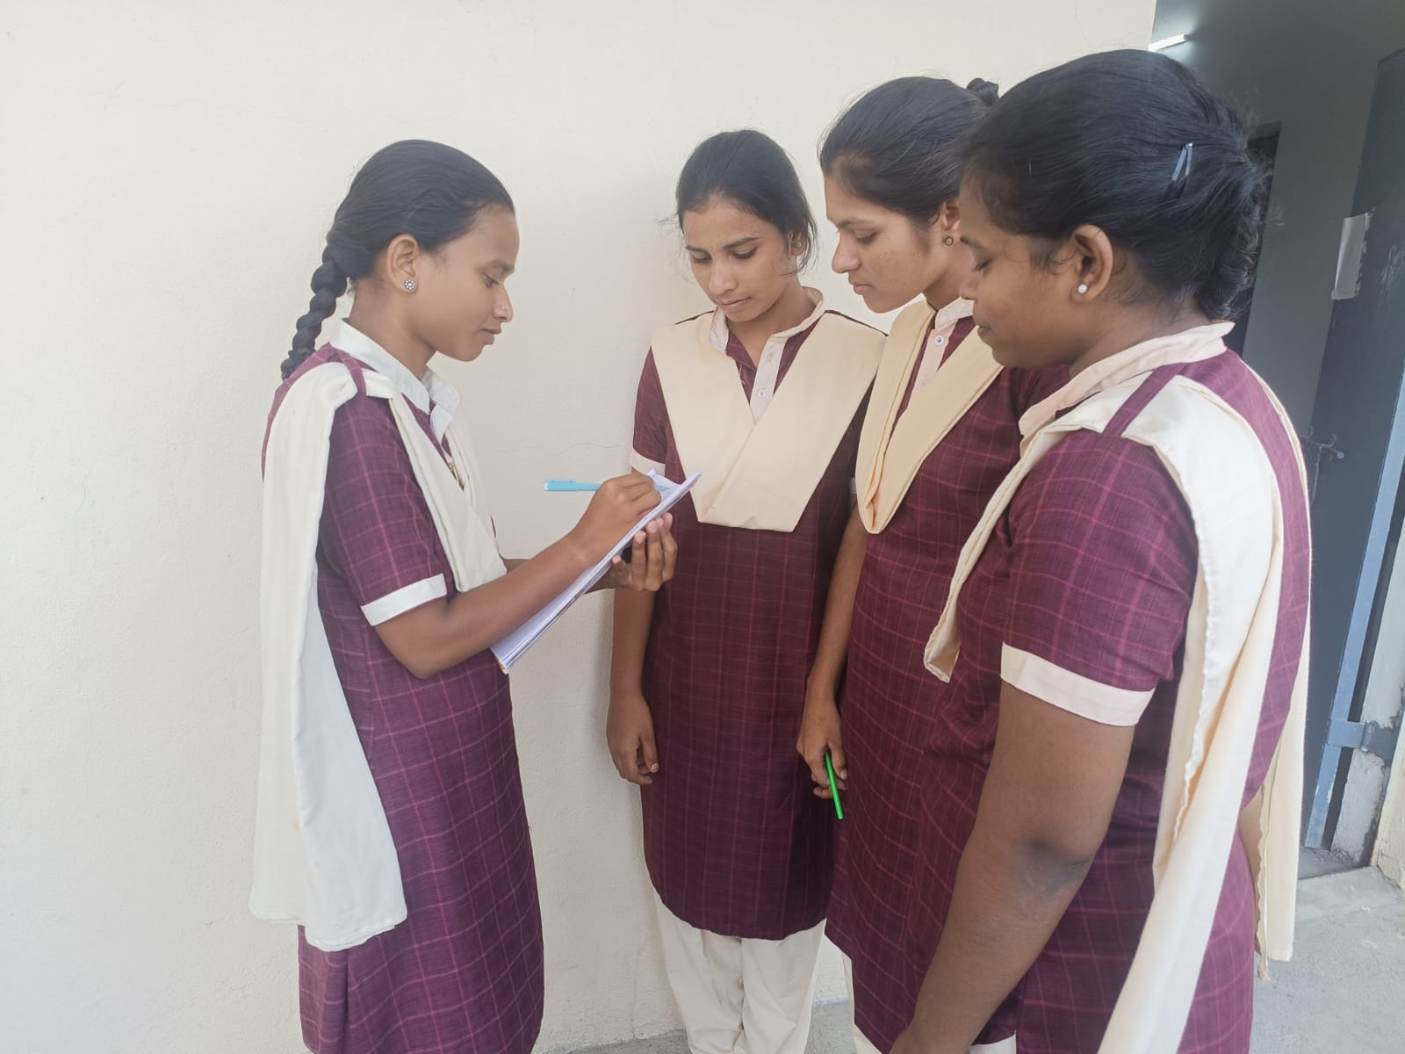

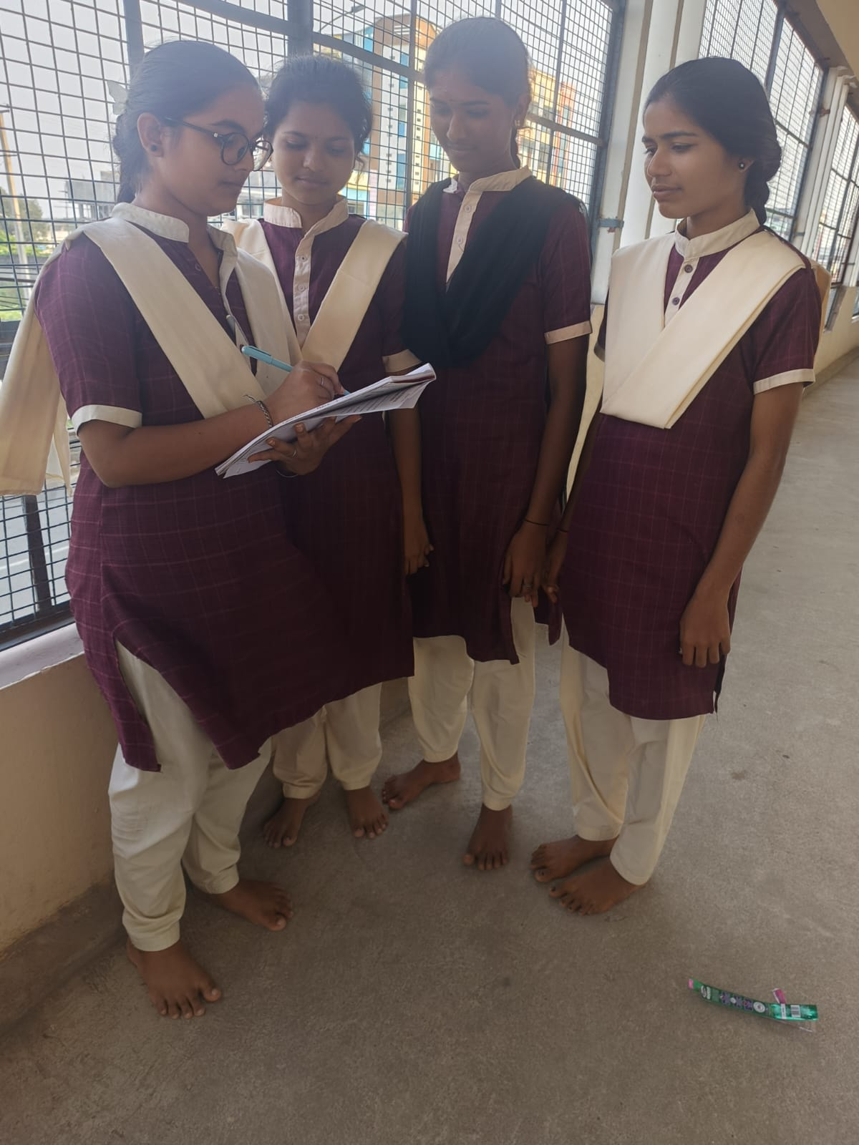

After conducting the survey or students conclude that most of the people are interested to eat healthy food Only Clive vegetables and pulses). Somebody to take mille in every day. They are not interested to eat fast food.